Cloud Video Conferencing Service. Internet Video Conferencing

[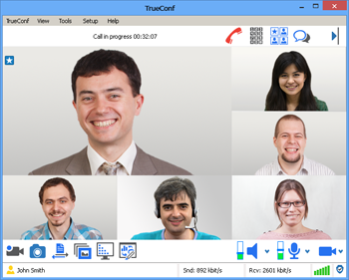](https://trueconf.com/images/a_multipoint/multipoint_en.png)

* Free FullHD calls and 3-way video conferencing
* Multipoint UltraHD video conferences with up to 120 participants
* Compatible with Windows, macOS, iOS and Android
* High video and audio quality on any Internet connection
* Trusted by over 3 million users worldwide

[Download TrueConf Online](https://trueconf.com/downloads/)  
[Create a corporate group](https://trueconf.com/products/online/registration/registration-team.html)

**TrueConf Online** is a cloud video conferencing service with a range of rich collaborative tools and an easy-to-use interface. TrueConf Online is a cost-effective solution for meeting with your partners and colleagues anytime, anywhere.

[Choose your plan](https://trueconf.com/pricing/online/plans.html)

Adobe Reader[More Info](https://trueconf.com/docs/trueconf_portfolio_en.pdf) →  
Adobe Reader[Corporate Group Guide](https://trueconf.com/docs/corp-group-administrator-guide.pdf) →  
Adobe Reader[How to install TrueConf Online?](https://trueconf.com/docs/installation-guide-tco.pdf) →

Compatible With All Platforms



For Mac and PC

Convert your laptop or desktop computer into professional video conferencing endpoint using your TrueConf Online application.



For Mobile Devices

Install the TrueConf mobile app to be able to host and participate in group video conferences anywhere.

[All client applications →](https://trueconf.com/downloads/)

Advantages of TrueConf Online Cloud Video Conferencing

* You do not need to host or rent a multipoint bridge: everything is managed through the cloud.
* You are able to enjoy video communication in any part of the world via the Internet.
* You save energy, time and money on [business trips](https://trueconf.com/video-conferencing-usage/business.html).
* You make your remote resource management more effective.
* You can enjoy a huge range of [collaboration tools](https://trueconf.com/features/collaboration/): chat, recording, slideshows, desktop sharing, and status tools.
* Due to [Scalable Video Coding (SVC)](https://trueconf.com/features/core/scalable-video-coding.html) technology, every participant receives the best possible video quality.
* TrueConf’s global coverage guarantees a great audio and video experience anywhere in the world.

[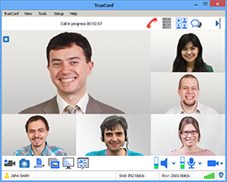](https://trueconf.com/images/a_multipoint/multipoint_en.png)

Group video conference

[](https://trueconf.com/images/videolecture_650_en.png)

Broadcasting

[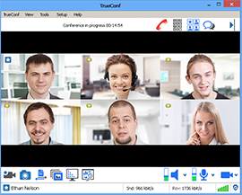](https://trueconf.com/images/role_984_en.png)

Virtual meeting

Compare TrueConf Online and TrueConf Server

* [TrueConf Server](https://trueconf.com/products/server/video-conferencing-server.html) users enjoy the advantages of videoconferencing through LAN, Internet, or on their virtual private network (VPN).
* TrueConf Server users can hold video meetings with up to 250 participants using various channels, including satellite channels.
* TrueConf Online service users can hold group multipoint video conference with up to 9 participants where everyone can be seen and heard by the others. By comparison, TrueConf Server users have access to multipoint video conferencing with 25 participants.
* TrueConf Server users have special options which allow delimitation of user rights or integration of TrueConf Server system with [SIP](https://trueconf.com/features/integration/multigateway.html)equipment.
* TrueConf Online users are able to pay monthly, whereas a TrueConf Server license is purchased for either a year or for an unlimited period.

**Notes**

1. Video calls are free, but Internet connection fees may apply.
2. To use the TrueConf Online service you will need a webcam, a microphone or headset, and Internet access.

[Video Conferencing Software](https://trueconf.com/)

 »

[Products](https://trueconf.com/products/)

 »

[TrueConf Online](https://trueconf.com/products/online/)

 »

[About Cloud Video Conferencing](https://trueconf.com/products/online/video-conferencing-service.html)